Step-1: Launch EC2 instance and connect it to VM

Step-2: go to /mnt folder create a .sh file = (Arithmatic.sh)

1. Sudo su - =go to root user
2. Cd /mnt = go to mnt directory
3. Vi arithmetic.sh = create .sh file for write shell script in it.

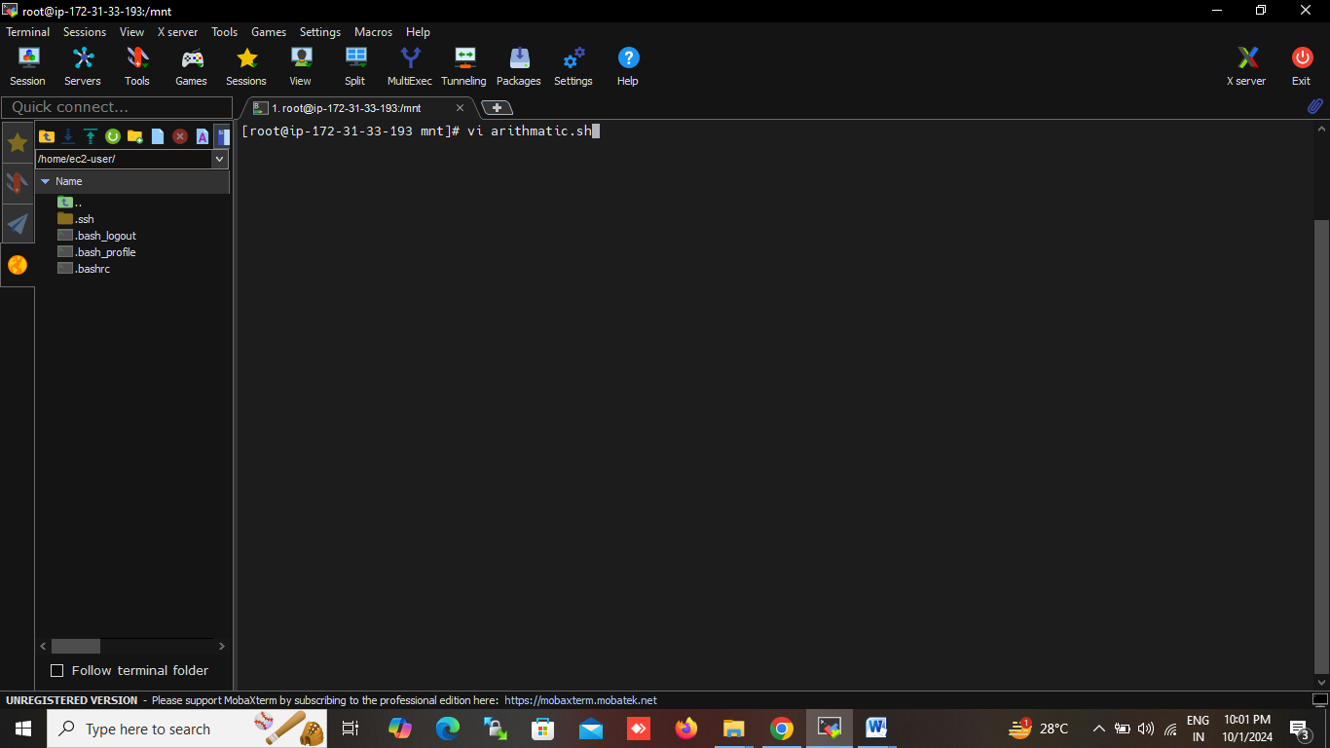

1. Write a simple shell script start with shbang statement = #!/bin/bash
2. #!/bin/bash

$a=30

$b=10

echo “first number: $a

echo “second number: $b

echo “Addition: $(( a + b))”

echo “substraction: $( (a – b))”

echo “multiplication: $((a \\* b))”

echo “division: $((a / b))”

echo “modulus: $((a % b))”

1. save the file and exit

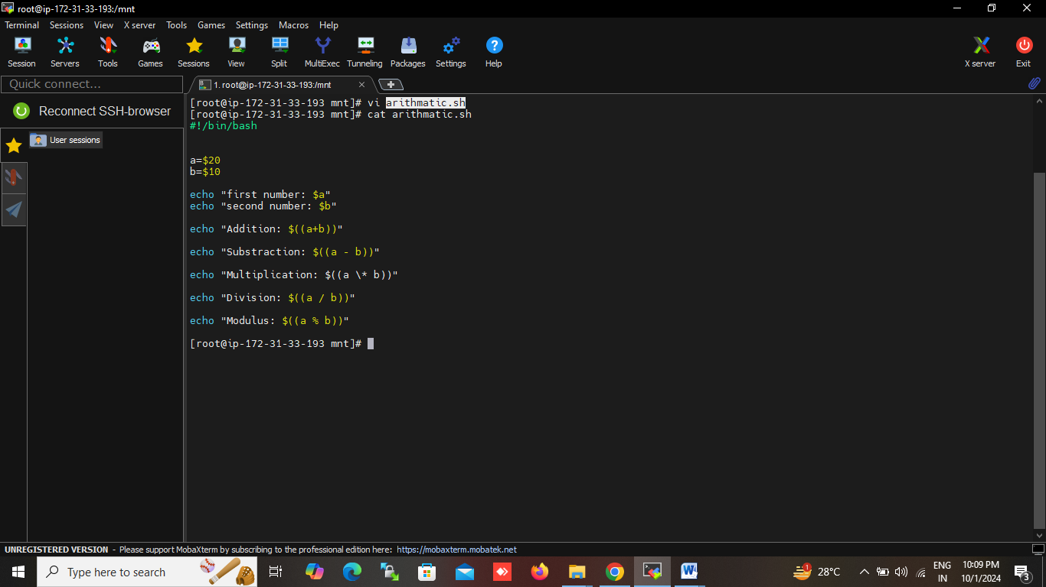

Step-3: set the permission to .sh file (give executable permission)

1.chmod 777 arithmatic.sh

Step-4: execute the file

1. ./arithmetic.sh

